Bahria University,

Karachi Campus



Course: SEN-221 – Software Design & Architecture

Term: Spring 2020, Class: BSE- 4B

Submitted By:

___SYED ALI ABBAS____________02-131182-070_____

(Name) (Reg. No.)

Submitted To:

Engr. Majid Kaleem/Engr. Rehan

Signed Remarks: Score:

Bahria University,

Karachi Campus



LAB ASSIGNMENT NO.

_______**3**_______

LIST OF TASKS

|  |  |
| --- | --- |
| TASK NO | OBJECTIVE |
| 1. | Implement Singleton pattern on printer functionality. |
| 2. | Implement Singleton pattern for Sessions. |
| 3. | Implement Singleton pattern for logger application. |
|  |  |
|  |  |
|  |  |
|  |  |
|  |  |
|  |  |
|  |  |

Submitted On:

___16-02-2020___

(Date: DD/MM/YY)

**Question 1:** Implement Singleton pattern on printer functionality.

**Code:**

**Main:**

Singleton obj = Singleton.GetObject();

obj.Print("Singleton pattern on printer functionality");

Console.WriteLine("Enter number of printer connected");

int number = int.Parse(Console.ReadLine());

obj.Printer(number);

obj.Print("Good Bye...!");

Console.ReadLine();_

**Singleton class:**

protected static Singleton _obj;

private Singleton() { }_

public static Singleton GetObject()

{

if (_obj == null)

{

_obj = new Singleton();

}

return _obj;

}

public void Printer(int num)

{

Console.WriteLine("{0} Printer are connected:",num);

Console.WriteLine("Enter Name of printers!");

string[] name = new string[num];

for (int i = 0; i < name.Length; i++)

{

name[i] = Console.ReadLine();

}

Console.WriteLine("Printer in Queue");

for (int j = 0; j < name.Length; j++)

{

Console.WriteLine("Printer No {0} = {1}",j+1,name[j]);

}

}

public void Print(string s)

{

Console.WriteLine(s);

}

**Output:**

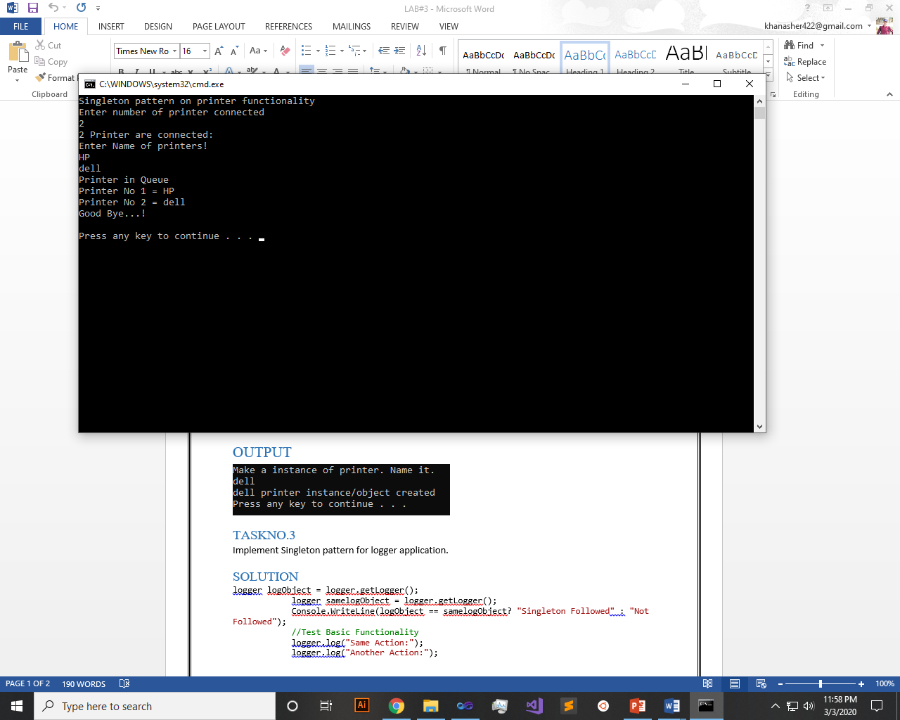

**Question 2:** Implement Singleton pattern for Sessions.

**Code:**

**Main:**

Session obj = Session.GetObject();

obj.Print("Singleton pattern for Session");

Console.WriteLine("Enter number of Sessions");

int number = int.Parse(Console.ReadLine());

obj.Printer(number);

obj.Print("Good Bye...!");

Console.ReadLine();

**Session class:**

protected static Session _obj;

private Session() { }_

public static Session GetObject()

{

if (_obj == null)

{

_obj = new Session();

}

return _obj;

}

public void Printer(int num)

{

Console.WriteLine("{0} Sessions are connected or exist:",num);

Console.WriteLine("Enter Name of Sessions!");

string[] name = new string[num];

for (int i = 0; i < name.Length; i++)

{

name[i] = Console.ReadLine();

}

Console.WriteLine("Each Sessions in a Sequence");

for (int j = 0; j < name.Length; j++)

{

Console.WriteLine("Session {0} = {1}",j,name[j]);

}

}

public void Print(string s)

{

Console.WriteLine(s);

}

**Output:**

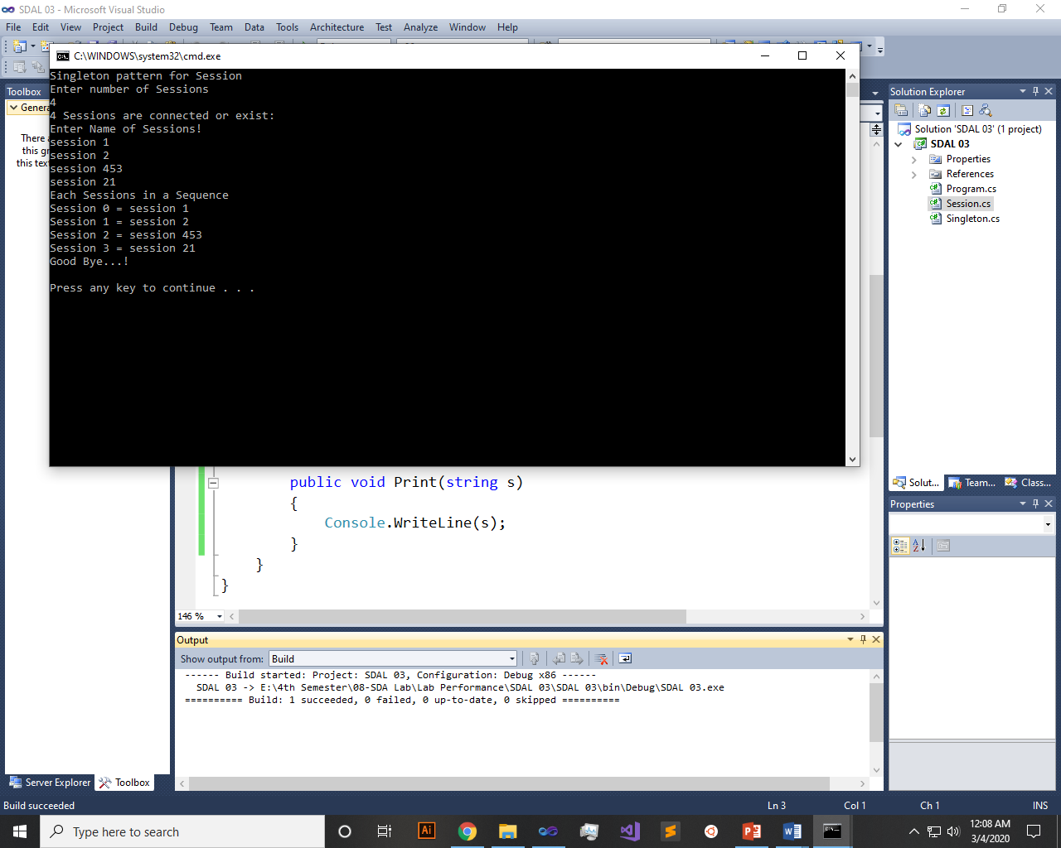

**Question 3:** Implement Singleton pattern for logger application.

**Code:**

**Main:**

Logger obj = Logger.GetObject();

obj.Print("Singleton pattern for Logger");

Console.WriteLine("Enter number of Logs");

int number = int.Parse(Console.ReadLine());

obj.Printer(number);

obj.Print("Good Bye...!");

Console.ReadLine();

**Logger Class:**

protected static Logger _obj;

private Logger() { }

public static Logger GetObject()

{

if (_obj == null)

{

_obj = new Logger();

}

return _obj;

}

public void Printer(int num)

{

Console.WriteLine("{0} Logger app are connected or exist:",num);

Console.WriteLine("Enter Name of logs!");

string[] name = new string[num];

for (int i = 0; i < name.Length; i++)

{

name[i] = Console.ReadLine();

}

Console.WriteLine("Each logs in a Sequence");

for (int j = 0; j < name.Length; j++)

{

Console.WriteLine("Date n Time : {2} : Log {0} = {1}",j,name[j],DateTime.Now);

}

}

public void Print(string s)

{

Console.WriteLine(s);

}

**Output:**

